

Project management course
Group 18
Programme Charter

Project Charter - Project 1
The Scope of Work of project 1 is to design and erect a plant producing internal components of an automotive combustion engine. The building will be constructed in Gora Padao Haldwani, India, and the project partner, Global Prime Cars, has already acquired the land indicated.
The first phase of the project is the Engineering Phase and involves the definition of the production process and its layout. Using concurrent engineering, we have assumed that both tasks can be performed simultaneously, but to do this, we must establish strong communication between the Italian and Indian engineering teams.
To perform the crash of project 1 we selected those tasks which were crashable, namely those along the critical path where we were able to add additional resources.
Then, we calculated the new durations once we knew the new amount of resources allocated to each task. For some tasks, we computed several options since more than one resource was available for such task.
For the task “Detailed Engineering process” we had 3 options:
- Add 1 Italian Specialized Engineer;
- Add 1 Italian Project Engineer;
- Add 1 Italian Specialized Engineer and 1 Italian Project Engineer;

For each of these options we calculated the duration once the task was crashed, the new cost considering that each crashing unit earn double of the rate of a normal employee and the overhead costs, computed as the overhead rate multiplied by the days of reduction.
The total cost of the crashing operation is given by the sum of these two costs.
We performed the same reasoning for the “Detailed engineering layout”.
The second phase is that of the Civil Works Refurbishment Erection Phase, which is entirely allocated to the owner of the plant, namely Global Prime Cars. We have assumed that the tasks can overlap by a time frame ranging from 10 to 25 days, so as to significantly reduce the time taken by the entire phase. The most important task is that of Flooring, since only once the latter is completed at least 50%, the machines can arrive at the site and can therefore be installed.
In order to ensure proper coordination between the two companies, a meeting was agreed between the parties at the end of the phase.
At the same time as the previous phase, the Purchasing Process takes place, linked to the purchase of all the machinery necessary for production. Regardless of the manufacturer chosen to purchase the machinery, orders are divided according to the type of machine in question. All orders are placed by a Purchasing Agent.
In the following table (Table 1) are shown the machineries with the relative suppliers
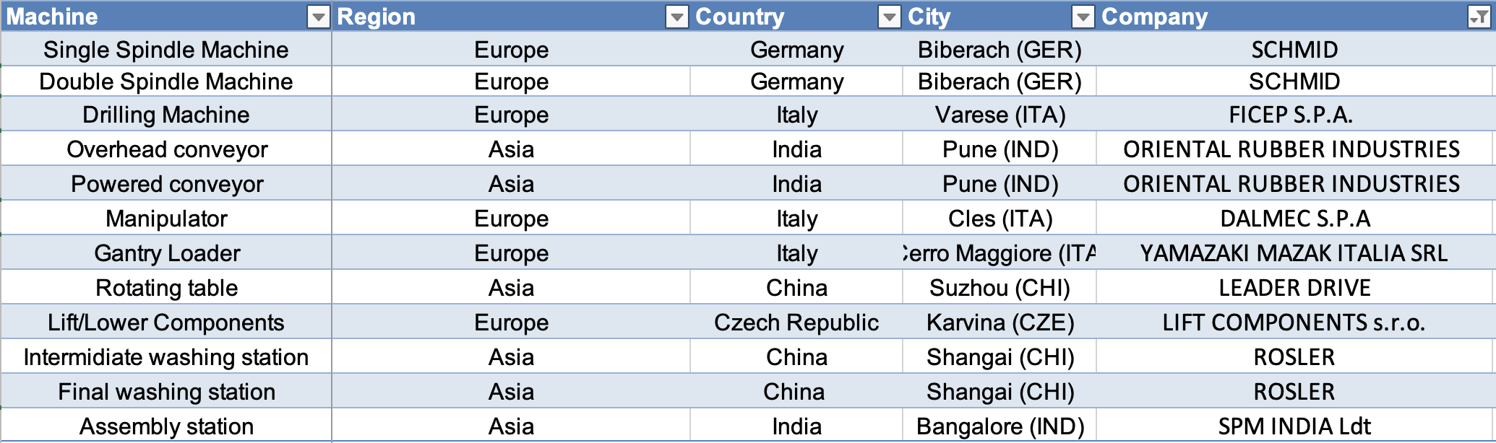
Table 1: Ordered machinery and relative suppliers
The next phase is the Equipment Manufacturing Phase and involves the manufacture by suppliers of the machines chosen in the previous phase. In this phase it happens also the payment of all the machinery, made by the purchasing agent: this task acquires relative importance as it represents a temporal constraint to the start of the project 2 and the project 3.
Once the machine construction tasks are completed, the Trasportation Phase takes place, in which the various suppliers send their products to our Indian plant.
Three modes of transport linked to the location of the supplier have been identified: these modes are listed in the Table 2. In Table 3 we have calculated the total cost for the transport of the machinery: in order to arrive to such figure we have calculated how many TEU are moved for every machinery (this figure is rounded up because the containers used for transport can only be rented in full) and we have multiplied them by the cost of that route by TEU.
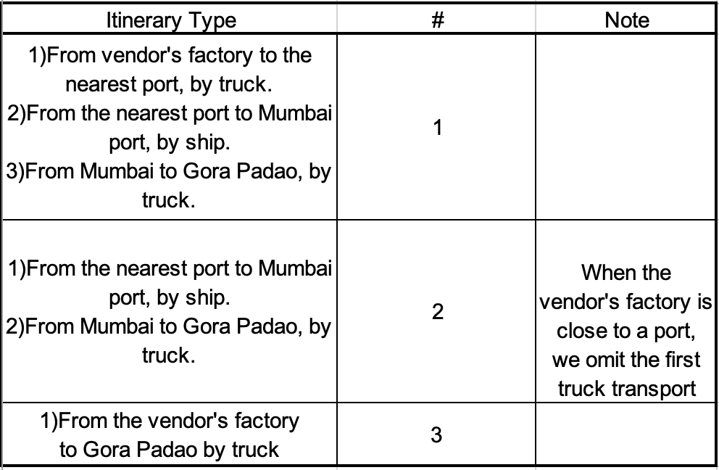
Table 2: types of routes identified
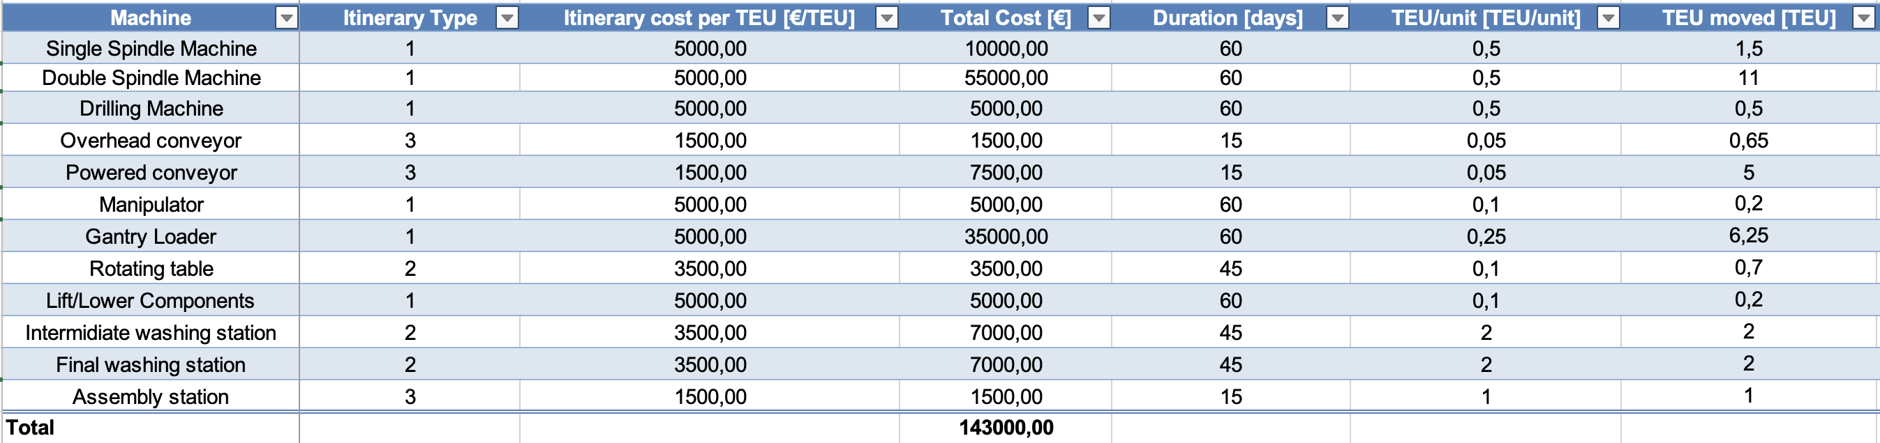
Table 3: machinery and respective itinerary type and cost
The TEU moved has been calculated by multiplying the TEU/unit by the number of machineries required for our plant.
$$TEU moved=TEU/unit⋅number of machinery required$$
Then, we calculated the total cost by multiplying the TEU moved (rounded up to the first integer number, as we cannot rent only a part of the TEU) by the itinerary cost per TEU
$$Total Cost=\left\lceil TEU/unit\right\rceil ⋅Itinerary cost per TEU$$
At this stage, finish to finish relationships have been used compared to the flooring task, as to get the machines to their destination it is necessary that at least 50% of the flooring is completed.
The rate of completion of the flooring for the arrival of the products varies from machinery to machinery, as we have assumed that the staggered arrival of the machinery involves a lower risk of accidents, caused by the excessive stock of machinery on the unfinished pavement.
The next step is the On Site Erection Phase. The order of operations was decided on the basis of the arrival of the machinery, taking into account that up to 3 operations can be carried out in parallel.
Hence, we come out with the following orders of operations:
- OP. 20$→$OP.30$→$OP.50$→$OP.100
- OP. 60$→$OP.40$→$OP.90
- OP. 70$→$OP.10$→$OP.80$→$OP.110

The last identified phase is Final Testing. This phase is important because, following its completion, it will also be possible to complete the test phases of project 2 and project 3.
Crashing
To perform the crash of project 1 we selected those tasks which were crashable, namely those along the critical path where we were able to add additional resources.
Then, we calculated the new durations once we knew the new amount of resources allocated to each task. For some tasks, we computed several options since more than one resource was available for such task.
For the task “Detailed Engineering process” we had 3 options:
- Add 1 Italian Specialized Engineer;
- Add 1 Italian Project Engineer;
- Add 1 Italian Specialized Engineer and 1 Italian Project Engineer;

For each of these options we calculated the duration once the task was crashed, the new cost considering that each crashing unit earns double of the rate of a normal resource and the overhead costs, computed as the overhead rate multiplied by the days of reduction.
$$Costs=2⋅wage rate ⋅days of work$$
$$Overheads=1000 ⋅ days of reduction$$
The total cost of the crashing operation is given by the sum of these two costs.
$$Total costs=costs+overheads$$
We performed the same reasoning for the “Detailed engineering layout”.
We also decided to do a crashing activity on the Erection phase, adding 3 teams of indian workers to those already present: this allows us to halve the duration of the tasks that were on the critical path. We didn’t add the Italian workers teams because they don’t participate in tasks that are on the critical path. In addition, we preferred to halve the durations of some tasks rather than have the crashing team perform tasks in parallel (thus having 4 paths in parallel in total) because this allows us to have a smoother allocation of resources. This reasoning is highlighted by the following images:

Figure 1: tasks duration when the crashing team is used to shorten the duration of some activities

Figure 2: tasks duration when the crashing team is used to perform 4 tasks in parallel
Concerning the last phase, Final testing, we evaluated if it was worth to perform the crash. We have identified 6 possible options, namely:
- Add 1 specialized engineer;
- Add 2 specialized engineers;
- Add 3 specialized engineers;
- Add 1 team of workers;
- Add 2 team of workers;
- Add 3 team of workers;

We performed the same reasonings as before, but in this case the costs were too high if compared with the reduction in the overall duration. Hence, we decided to not perform any crash on this task.
All the costs are shown in the Table 3. In the computation of the final total costs, we considered only those highlighted in bold, as that were the actual crashing we decided to perform. The total cost given by these operations is equal to €513 160, with a total reduction of 340 days.
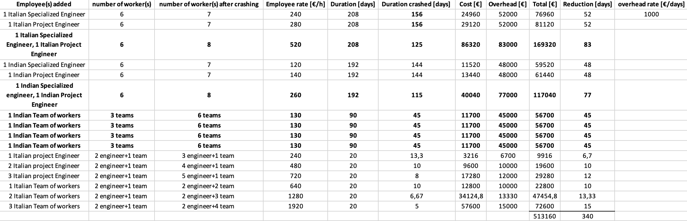
Table 4: crashing options. Only the bald operations have been actually implemented.

Project 2: ERP implementation

One of the primary objectives of the ERP is to provide a centralized platform for managing a wide range of critical operations. The integration of various departments and functions allows ERP systems to streamline processes, enhance efficiency, and promote data integrity, thereby fostering organizational success. They effectively eliminate data duplication by aggregating transactional data from multiple sources into a single centralized collection. The only constraint for this project is that it can only commence after the completion of the manufacturing phase.
The initiation of Project 2 occurs upon the conclusion of the manufacturing phase described in Project 1, hence it starts on the 15/01/2025 We have assumed that Projects 2 and 3 can commence concurrently. ERP implementation is crucial as its completion marks the beginning of the "Enable action by removing barriers" phase of Project 3. At the conclusion of Project 2, our team has scheduled a meeting to ensure that the ERP system implemented aligns with the overall objectives of the company. We have assumed that the testing phase of Project 2 can only begin upon the completion of the testing phase of Project 1.
The main assumption we made is that, for those tasks along the critical path, we can reduce the duration accordingly to the number of resources assigned.
The estimated completion date is 06/07/2026.
Thanks to the collaboration with an ERP consulting team, our company expects a system that will reduce operational costs through process optimization and enhance services with shorter response times. Additionally, by utilizing a unified platform, we anticipate improved collaboration between departments and greater reliability of corporate data.
Within an overall cost of approximately €25 million, the ERP system implementation is projected to cost €205,682.00, with an additional €2,000.00 allocated for the concluding meeting with stakeholders.
Three primary entities are involved: Magnus Italy, Magnus India, and the ERP consultant.
For Magnus Italy, the professional roles involved include: CEO, Functional Managers, and Functional Professionals.
For Magnus India, the professional roles involved comprise: CEO, Functional Managers, Functional Professionals, Human Resources, and Information Technology.
Regarding the ERP consultant, the roles involved are: Project Director, ERP experts from the Italian team, Business Analysts from the Italian team, and ERP professionals from the Indian team.

Project 3: Platform
Recognizing the shortcomings of its traditional functional structure overlaid on a macro-operation process, Magnus is preparing to change the complex network of organizational relationships hindering effective application development. Despite delivering specialized functions, this approach falls short of desired outcomes, particularly in monitoring and controlling development phases. The primary issue lies in the lack of clear accountability for development costs and quality metrics among application engineers and personnel. To address this, Magnus proposes a transformative shift to a matrix organization. Accordingly, the “Platform” project aims to establish a platform/program approach to product management, where specific customer applications are developed within a program of similar products.

Setting the change process into motion necessitates creating a compelling sense of urgency among both managers and employees. It is imperative that all stakeholders not only acknowledge the imperative for change but also grasp its fundamental role in propelling organizational growth. To do so, the shift to the matrix organization must consider both the opinions of employees and of industry expert regarding the current challenges and the necessity for change. Various teams of experts, described in the next paragraphs, must create a new corporate vision to show employees and customers the organization's desired future state.

Several obstacles can be encountered in this process, ranging from deficient processes to employee resistance and misaligned policies. In this phase, the guiding coalition and senior management play a pivotal role in recognizing and dismantling these barriers. A thorough review of processes, structures, policies, rewards, and communication channels is essential.

Once this is accomplished, management must create a set of medium-to-short goals that can be achieved and celebrated early in the process to maintain momentum. The last step of the project entails a transformation of organizational norms, values, processes, reward systems, and infrastructure elements, all harmonized to seamlessly align with the new company’s vision.

Moving on instead in the relationship of this project with the other initiatives, it can be seen that once the machinery needed in Project 1 has been secured and compensated for, a meeting is held among all stakeholders in Project 3 to initiate the planned activities. The activities have an expected start date on 01/15/25, all other tasks will follow a linear development, free from any specific time constraints. Only with the phase called "Removing barriers" will there be an iteration with Project 2. To identify inadequate processes, the senior guiding team will have to wait until the end of testing and then the beginning of the deployment of Project 2; this task is expected to begin on 06/04/26. A meeting is scheduled for the end of the project, which occurs between the project sponsor and the Italian CEO of Magnus. The purpose of the meeting is to showcase the progress achieved thus far.

Regarding the entities and resources involved, the first phase of the project will be completed by a team of business analysts who are industry experts and will analyse the future scenarios in which the company will have to navigate. Once this phase is completed, the "Building Guiding Coalition" phase will begin. In this phase all the key teams participating in the project will be created. In particular, the CEO of Magnus will choose the project sponsor, who in turn will designate the members of the Senior Guiding Team: the latter team will be empowered to make decisions on the new company’s vision, resource allocation, and removal of barriers hindering the success of the project. The Senior Guiding Team, together with the sponsor, will select the Field Guiding Team, which will have the role of communicating the vision and to guide the organization throughout the process. The last team that will participate in the project is the Change Team, who as true project managers will oversee bringing the tasks to completion within the agreed limits and simultaneously support the teams already mentioned in more complex decisions.

Moving on the expected outcome, it can be seen that completion of Project 3 will enable the new factory to have its own product development capability, which will have the direct effect of lowering production costs. Moreover, before the completion of project 3, products produced in India but designed in Italy will have an EBITDA profit margin (EBITDA / Sales) equals to 9%, instead after the completion of the project the profit margin for products completely developed in India is expected to be at 14%.

Lastly, regarding time and cost, the project will start on 01/15/25 and has an expected completion date on 06/23/26, with an expected cost of €337.752,28.

Attachment
Summary project charters
Project name | Project 1
Stakeholders | Global prime cars, Italian partner
Objectives and Potential Constraints | The main objective of this project is to design and build a facility situated in Gora Padao Haldwani, India. It must be complete in all its parts, including the design of the process layout and the erection of the machineries needed. The plant has to produce internal components of an automotive combustion engine and is the result of a partnership between our Italian firm and Global Prime Cars.
Relationships with other Initiaitives | The project starts on 15/01/2024. The main phases are: Engineering Phase, Civil Works Refurbishment Erection Phase, Purchasing Process, Equipment Manufacturing Phase, Transportation Phase, On Site Erection Phase and Final Testing.
Entities and Resources Involved | There are several entities involved. The Owner is the one responsible for the construction of the building. The supplier is responsible for the manufacturing of the equipment and the logistic service provider for the transportation.  All the other tasks are performed by the Italian and Indian Specialized Engineer, the Italian and Indian Project Engineer, the Purchasing Agent and the Italian and Indian team of workers
Expected Outcomes and Scheduled Dates | The expected outcome of the project is the realization of a fully working establishment, complying with the resources and time constraints. The project is expected to start the 15/01/2024 and completed within 547 days, on the 17/02/2026
Cost Estimate | The overall cost is equal to 24 600 000€

Project name | Project 2: ERP implementation
Stakeholders | Magnus Italy, Magnus India, ERP expert
Objectives and Potential Constraints | The main objective of this project is to develop the ERP system.  The constraint is that it can start only after the completion of the manufacturing phase on Project 1
Relationships with other Initiaitives | We assumed that Projects 2 and 3 can commence concurrently.  ERP implementation phase completion marks the beginning of the "Enable action by removing barriers" phase of Project 3.  We assumed that the testing phase of Project 2 can only begin upon the completion of the testing phase of Project 1.
Entities and Resources Involved | Magnus Italy, Magnus India, and the ERP consultant.  For Magnus Italy, the professional roles involved include: CEO, Functional Managers, and Functional Professionals.  For Magnus India, the professional roles involved comprise: CEO, Functional Managers, Functional Professionals, Human Resources, and Information Technology.  Regarding the ERP consultant, the roles involved are: Project Director, ERP experts from the Italian team, Business Analysts from the Italian team, and ERP professionals from the Indian team.
Expected Outcomes and Scheduled Dates | The Project commences on 04/11/2024, with an anticipated completion date of 06/05/2026.  We expect a system that will reduce operational costs through process optimization and enhance services with shorter response times. Additionally, by utilizing a unified platform, we anticipate improved collaboration between departments and greater reliability of corporate data.
Cost Estimate | Within an overall cost of approximately €25 million, the ERP system implementation is projected to cost €205,682.00, with an additional €2,000.00 allocated for the concluding meeting with stakeholders.

Project name | Project 3: Platform
Stakeholders | Magnus Italy, Magnus India
Objectives and Potential Constraints | The main objective of this project is to establish a platform/program approach to product management, where specific customer applications are developed within a program of similar products. The constraint is that it can start only after the completion of the manufacturing phase on Project 1, and the Test phase of project 2.
Relationships with other Initiaitives | We assumed that Projects 2 and 3 can commence concurrently.  ERP implementation phase completion of project 2 marks the beginning of the "Enable action by removing barriers" phase of Project 3.
Entities and Resources Involved | The project will be carried on by a business analyst and a Guiding Coalition. The Guiding Coalition will composed of a Sponsor, Senior Guiding Team, Field Guiding Team, Change Team. The Sponsor will be decided by the CEO and then each team will be chosen by the previous team in the order listed.
Expected Outcomes and Scheduled Dates | Project 3 will enable the new factory to have its own product development capability, which will have the direct effect of lowering production costs. EBITDA profit margin (EBITDA / Sales) will go from 9% to 14%.  The project will start on 01/15/25 and has an expected completion date on 06/23/26
Cost Estimate | Platform project has an expected cost of €337.752,28.

